DEED OF GIFT

I place in the custody of the Island Heights Yacht Club a sterling silver trophy to be known as the
ERNEST D. HANGARTER PERPETUAL TROPHY

and to be sailed for under the following conditions:
- This trophy is to be sailed for by Class "B” Sneakboxes on Barnegat Bay and vicinity, each Class "B" Sneakbox to be owned by a member of a Club which is a member of the Barnegat Bay Yacht Racing Association. If at any time in the future the class should be discontinued, the trophy reverts to a class chosen by the Island Heights Yacht Club.
- The race for this trophy will be the regularly scheduled Barnegat Bay Yacht Racing Association Regatta held by the Island Heights Yacht Club.
- Boats are to be wholly manned and sailed by amateur crews composed of members of the competing yacht clubs.
4. The boat winning the trophy is to have engraved thereon, in small characters, the name of yacht and owner, club and date of race. The skipper winning the race is to be custodian of the trophy for the year in which it was won, and prior to the race for the following year is to be returned to the Island Heights Yacht Club to be again contested for. A receipt shall be given by the owner of the winning sneakbox agreeing to comply with this article,,
5. If at any time in the future the Island Heights Yacht Club should no longer be a member of the Barnegat Bay Yacht Racing Association, then this trophy shall be sailed for under the jurisdiction of the Island Heights Yacht Club.
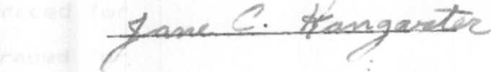
July 18, I960

